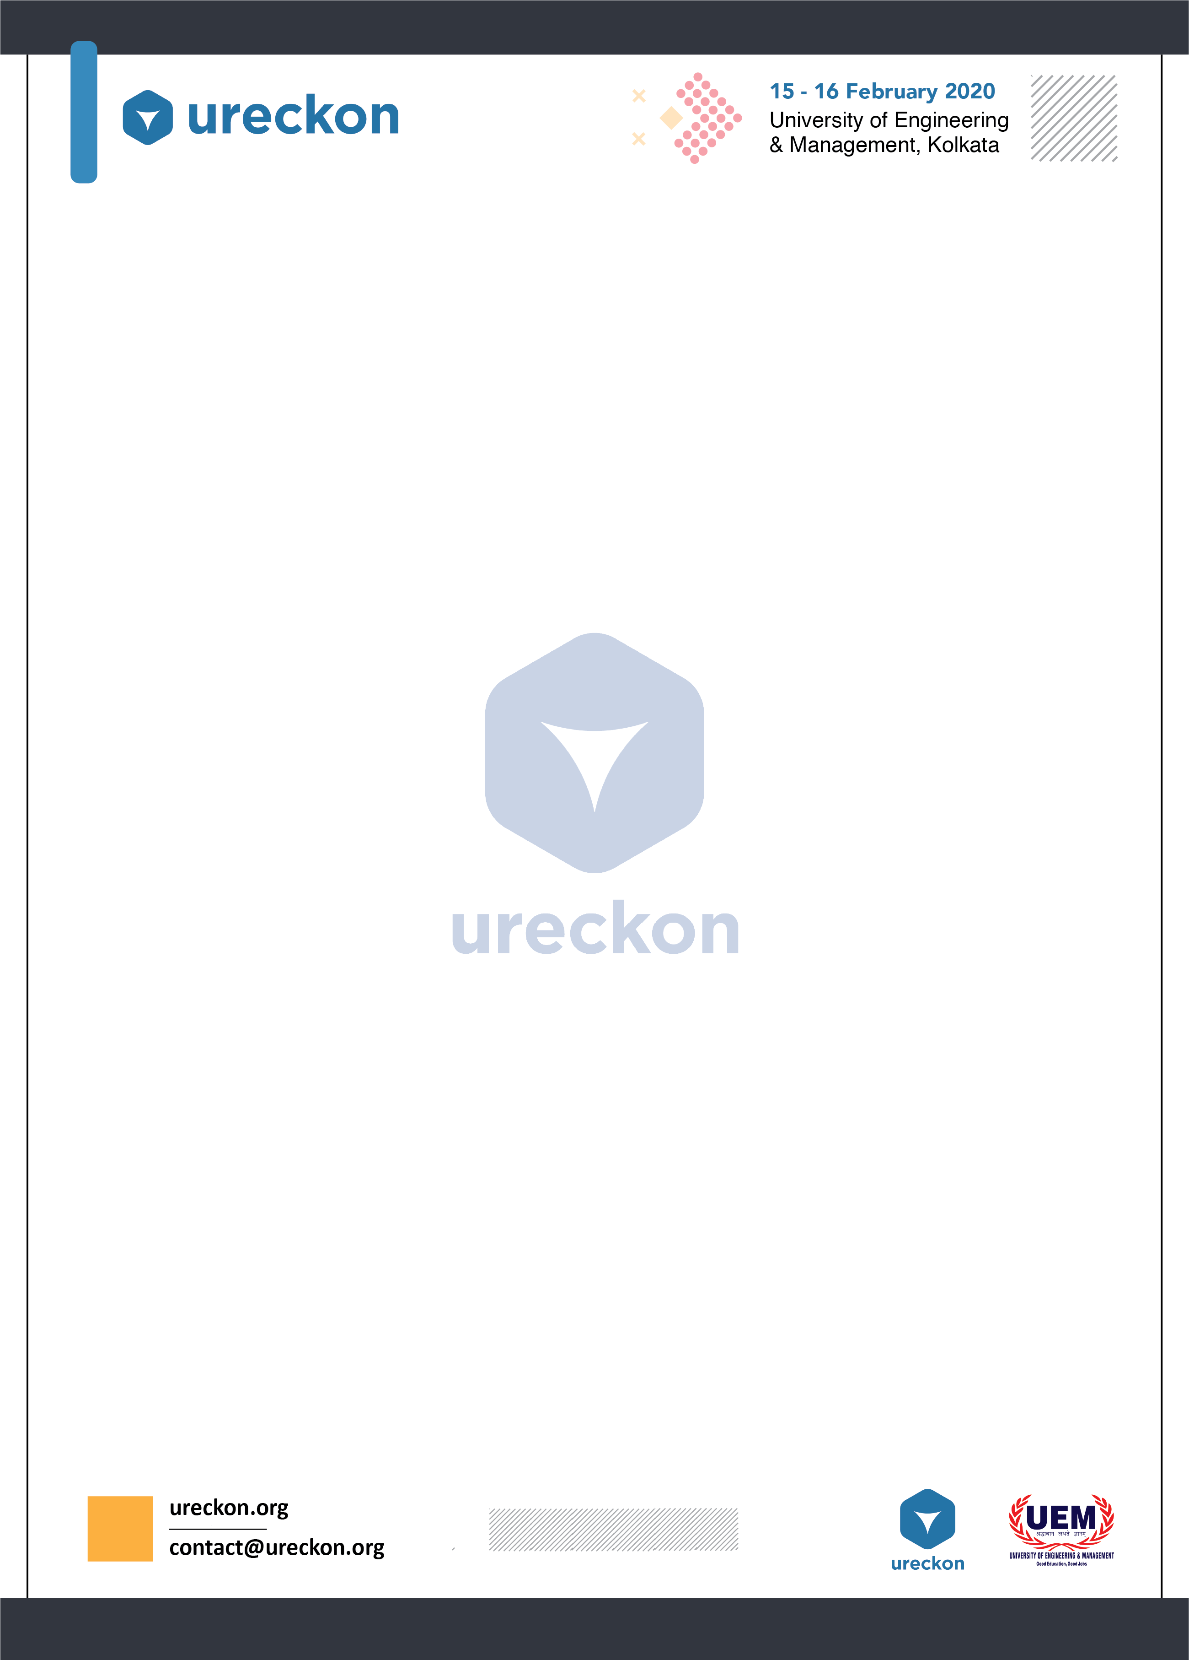

**Operation Darkstorm**

**Operation Darkstorm** is a 2v2 competitive mode of the most famous fps **Counterstrike Global Offensive** also known as Wingman. Each team is required to have a minimum of 2 players. Any registration not having met the minimum number of members will be considered void as we are **not accepting solo participation.**

Each member has to be registered with their official gamer tags and also their real names and once registered no changes to the line-up will be allowed. Team Names once registered cannot be changed either. All names must not infringe any copyright or trademark logos and neither be offensive nor toxic in any nature.

**About the tournament**

* Max number of players playing at a time per team – 2
* Win Condition – Race to 9 wins out of 16 rounds.
* Any form of cheating will get the team disqualified and by default the opposition team wins.
* No trashtalking, hooting or swearing.
* Official Competitive rules apply.
* **Fixtures will be declared on the event date.**
* **Map pool: -**
  + **Inferno**
  + **Overpass**
  + **Train**
  + **Vertigo**
  + **Nuke**
  + **Shortdust**
  + **Rialto**

**Game Rules: -**

1. Each round consists of 1 mins 30 seconds.
2. After 8 rounds sides will be swapped.
3. Friendly Fire will remain on but teamkilling is prohibited and getting banned due to excessive team damage will result in disqualification.
4. Map Veto will be started by a coin toss. The team winning the toss will ban the first map.
5. Side selection will be done by a Knife round (Winning team gets to select the side).
6. One tactical timeout is allowed per team. No other pause time will be rewarded.
7. Loading of custom config files will only be allowed under the supervision of admin.
8. Abusing any glitches and pixelwalking is strictly illegal and will result in an immediate disqualification.
9. Any form of scripting will result in disqualification.
10. Wild cart entry will only be allowed under discretion of admins during a presence of an odd number of teams.
11. Bring your own mouse, mousepad, keyboard and headphones (Else use inferior workplace equipments).
12. Any payment made at the registration desk is non refundable.
13. Failure to be present at the venue on time might result in disqualification.
14. Auto Snipers are not allowed.
15. All teams will be given 5 mins to setup and warmup.

**Decision of an admin is final and binding and can only be reverted by the one taking the decision.**

**Any queries contact: -**

* **Swagatam Biswas**

Phn. No.- 9051582873

* **Rohit Chakraborty**

Phn. No.- 8240253578

**We have limited registration space available so once all seats are filled we will stop taking registrations.**